**ECE374 Assignment 4**

Due 03/06/2023

**Group & netid**

*Chen Si chensi3*

*Jie Wang jiew5*

*Shitian Yang sy39*

**Problem 4**

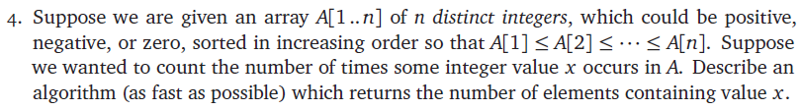

Solution:

Intuition: as the array is sorted, all occurrences of a number x must be consecutive. Therefore, we could solve this problem by using a binary search for the left bound of the consecutive xs and then use another binary search for he right bound of the consecutive xs. A subtraction of the indices would give us the number of xs.

Algorithm:

NUMBER_OF_X (A, x):

# binary search for the left most x

l = 0

r = length(A) – 1

left_most = None

while (l <= r):

m = floor ((l + r) / 2) # use floor to avoid the case of

# can’t reach 0 (l=0, r=1, m=0.5🡪1)

if (A[m]>=x):

left_most=m

r = m - 1

else:

l = m + 1

# binary search for the left most x

l = 0

r = length(A) – 1

right_most = None

while (l <= r):

m = ceil ((l + r) / 2) # use ceil to avoid the case of can’t

# reach n-1 (l=n-2,r=n-1,m=n-1.5🡪n-2)

if (A[m] <= x):

right_most = m

l = m + 1

else:

r = m + 1

if (left_most != None and right_most != None)

return right_most – left_most + 1

else:

return 0

With two binary searches, the running time of this algorithm is O(log n)+O(log n)+O(1)=O(log n).